Chapter 10, Problem 38.

Using mesh analysis, obtain I_{o} in the circuit shown in Fig. 10.83.

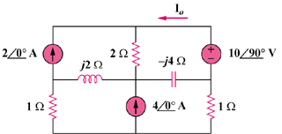

Figure 10.83
For Prob. 10.38.

